Word_count –pig Script

lines = LOAD'/home/acadgild/Desktop/hdf/word_count.txt' AS (line:chararray);

words = foreach lines GENERATE flatten(TOKENIZE(line, ' '));

group_words = group words by $0;

cnt_words = foreach group_words GENERATE group, COUNT(words);

ord_words = order cnt_words by $0;

dump ord_words;

Commands used are :

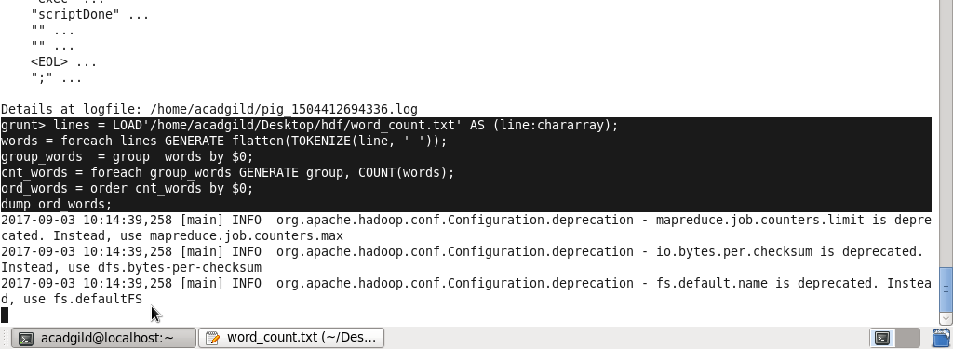

Output :

